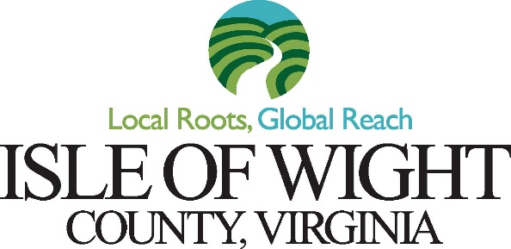

Department of Parks & Recreation
13036 Nike Park Road
Carrollton, Virginia 23314
(757) 357-2291 Fax (757) 365-0112

N e w s R e l e a s e

Contact Person: Jenilee Hallman

Date Sent: June 16, 2020

Release Date: As Soon as Possible

Re: Isle of Wight County July 4th Fireworks Show

Isle of Wight County will be hosting a Fireworks Show in Celebration of the Fourth of July on Saturday, July 4, 2020 at the Heritage Park Fairgrounds. This event will be a drive-in ONLY to adhere to safe social-distancing measures. Gates open at 7:30 pm and guests will be parked by staff.

Guests are required to stay in their vehicles. There will be no on-site restrooms available. Please keep all trash in your vehicles to dispose of at home.

American Fireworks Company will be displaying the fireworks show and will begin at approximately 9:30 pm or at dark.

For more information about the fireworks please contact Parks and Recreation at 757-357-2291.

