ECONOMIC INCENTIVES POLICY FOR THE ECONOMIC DEVELOPMENT AUTHORITY OF THE TOWN OF WINDSOR

Section I. Area of Applicability: The following Incentives Policy shall apply to that area of the Town of Windsor that has been designated by the Town Council of Windsor as the Town of Windsor Tourism Zone.

Section II. Scope and Eligibility: The economic incentives within this Ordinance may be made available to any new, expanded, or relocating business which meets the following qualifications of this policy and which seeks to attract customers from the region.

- Existing, new or relocating businesses shall qualify if they are located within the Windsor Tourism District and build new buildings or structures, expand or improve existing buildings or structures, or perf01m site improvements in such a manner as to cause an increase of property values of $25,000 or more as evidenced by the increased Isle of Wight County assessment.

Section III. Economic incentives: The following economic incentives shall be provided to qualified applicants.

  - The Town of Windsor's Real Property Tax shall be fully reimbursed to the applicant by the Economic Development Authority of the Town of Windsor for that po1iion of the real property tax assessed which is based on the increase in value. This reimbursement shall be available to the applicant for three years after the increased assessment takes effect.

  - Fifty percent of the amount of the initial facility fee for water services as paid by the qualifying business shall be reimbursed.

Section IV - Administration
The Planning and Zoning Administrator or other designated employee from the Town of Windsor is authorized to administer the aforementioned program on behalf of the Authority. The Planning and Zoning Administrator shall develop an application form and process with other inf01mation that is required in order to determine whether the applicant for such incentives qualifies and if so for what time-frames. Applicants may apply and an initial informal dete1mination shall be made by the Planning and Zoning Administrator within thirty (30) days of the date of the receipt of all required information

- - - - - - - - - - - - - - - - - Page 1

for qualification to the program. Final detent inaction and approval of reimbursements to the qualifying business shall be made by formal action of the Authority at the next regular or special meeting. The Authority shall reimburse the qualifying business from Authority funds designating the amount and reasons for the rebate.
Section V. Disclaimer.
The Economic Development Authority may not be able to honor all requests for reimbursement within a given fiscal year. The Town of Windsor Economic Development Authority retains the discretion to deny a request in a fiscal year due to budgetary restraints. Such requests may be made again in a subsequent fiscal year and may be honored as such if they otherwise meet the qualifications of this Program.
Section VI. Continuous Review
The application policy, administration and incentives shall be reviewed by the Economic Development Authority on an annual basis to insure the integrity, efficiency and effectiveness of the program. The analysis of such review may be made and forwarded to the Town Council of the Town of Windsor by March 1s t of each calendar year for their use in determining budgetary assistance.

- - - - - - - - - - - - - - - - Page 2

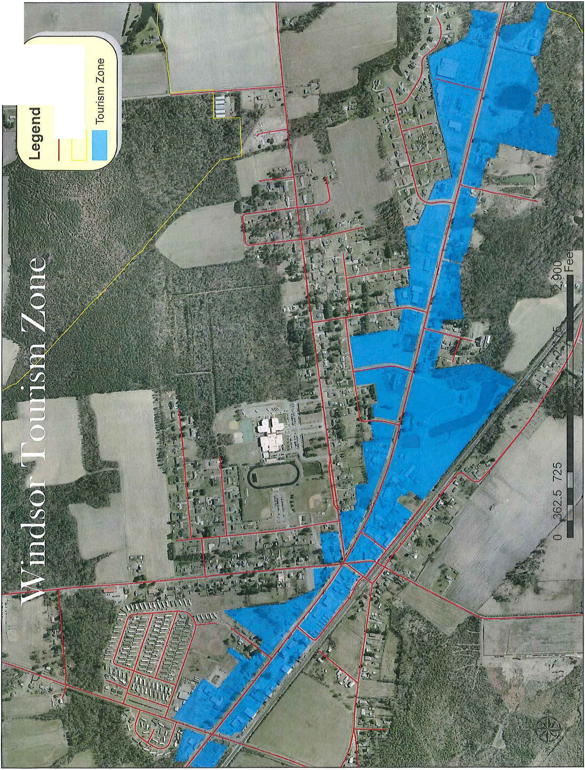
en
-0
ro
0
CY
._I
0en
-0
C

tJ) '- Q)
-0
'--
c0o
C
3

